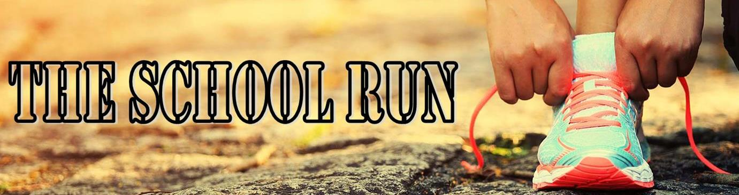

Daily Mile Medals 2021
Registration Form
Contact Name ___________________________________________________________________________
School Name ____________________________________________________________________________
Address ________________________________________________________________________________
_______________________________________________________________________________________
Post Code ______________________________________________________________________________
Telephone Number_______________________________________________________________________
Email Address ___________________________________________________________________________
Email Address of Finance Officer ____________________________________________________________
Date that you require your medals _________________________________________________________
For £2.99 per child you will receive:
- A high quality medal with ribbon.
- A certificate to download
I would like _________ Daily Mile medals at a cost of £2.99 per child.
Colour of background and ribbon _________________________
Text to go on the bottom of the rim ______________________________

Name _________________________________ Signed ________________________________

Position ________________________________ Date _________________________________

The School Run 2021 – A trading name of the Primary Resource Centre
support@ukschoolrun.com

